T04: https://cos30045datavisualisationt04-phi.vercel.app/

T05: https://cos30045datavisualisationt05-five.vercel.app/src/

T06: https://cos30045datavisualisationt06.vercel.app

T07: Data Visualisation Design

Visualisation 1:
Website: (Not accessible anymore) https://www.reddit.com/r/DankLeft/comments/hwcf7v/slavery_was_never_abolished_in_the_us_its_still/
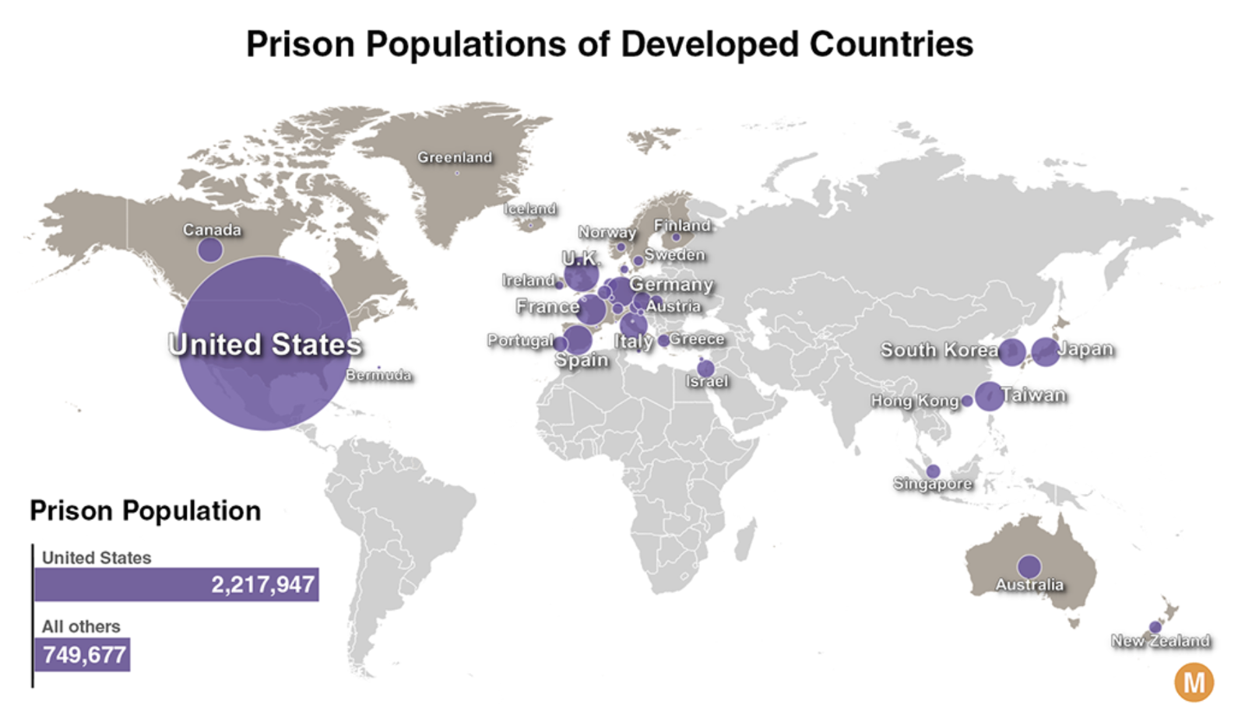

1. What appears to be the purpose of the chart?

The chart compares (prison population in developed countries) and highlights that the (US) has more prisoners than all the other countries shown combined.

2. What kind of chart is this?
A (bubble/symbol map), with a supporting (horizontal bar chart).

3. What data does it appear to be encoding and how is it encoding it?
Data encoded | Encoding method | Explanation
Prison population of each country | Bubble size | B. Larger bubbles mean more prisoners.
Country location | Geographic position | E. Bubbles show geographic locations.
Country identity | Text labels | C. Names identify countries.
Total prisoners: United States versus all others | Bar length | F. Longer bars mean more prisoners.
Country group | Text labels | D. Labels identify “United States” and “All others”.
Exact prison population totals | Numerical labels | A. U.S.: 2,217,947; all others: 749,677.

4. Are there any interactive features? If so, what are they and how are they used?
No, this chart is not interactive.

5. What features does it use to try to get its message across?
Feature | How it helps convey the message
Large U.S. bubble | C. Highlights the large U.S. prison population.
Geographic map layout | A. Provides geographic context.
Consistent purple colour | F. Keeps attention on size rather than colour differences.
Country labels and numerical totals | B. Identifies countries and exact counts.
Supporting bar chart | E. Clearly compares the U.S. and all-others totals.
Prominent title and U.S. label | D. Establishes the topic and main focus.

6. Which design do you think is best and why?

Design feature | Good design | Bad design
The bar chart clearly compares the U.S. total with all others combined. | ☒ | ☐
Overlapping labels make some European countries difficult to identify. | ☐ | ☒
Numerical labels show exact prison population totals. | ☒ | ☐
Overlapping bubbles make smaller populations difficult to compare. | ☐ | ☒
The map provides geographic context. | ☒ | ☐
The title clearly identifies the chart’s topic. | ☒ | ☐

Visualisation 2:
Website: https://www.pewresearch.org/short-reads/2021/08/16/americas-incarceration-rate-lowest-since-1995
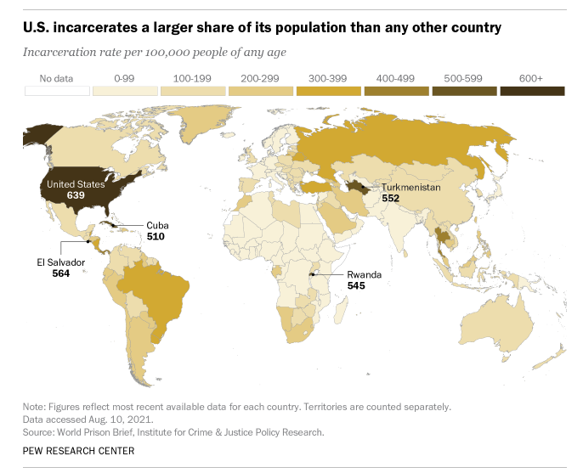

1. What appears to be the purpose of the chart?
The chart compares (incarceration rates) across countries and highlights that the (US) has the highest rate in the data presented.

2. What kind of chart is this?
A (filled/shaded/choropleth map).

3. What data does it appear to be encoding and how is it encoding it?
Data Encoded | Encoding Method | Explanation
Incarceration rate per 100,000 people | Colour shade | C. Darker shades represent higher rate ranges.
Country location | Geographic position | D. Countries appear at their map locations.
Selected countries and exact rates | Text labels | B. Names and numbers identify selected countries and rates.
Missing data | White fill | A. White indicates “No data”, as shown in the legend.

4. Are there any interactive features? If so, what are they and how are they used?
No, this chart is static.

5. What features does it use to try to get its message across?
Feature | How it helps
Sequential colour scale | C. Shows differences in incarceration rates.
World map layout | A. Provides geographic context.
Country names and numerical labels | B. Identifies selected countries and exact rates.
Prominent headline | D. States the main finding.
Colour legend | E. Explains the colour ranges and missing data.
Subtitle and source notes | F. Clarifies the measure, source and data timing.

6. Which design do you think is best and why?
Design feature | Good design | Bad design
Rates per 100,000 people support comparisons between countries of different population sizes. | ☒ | ☐
Ordered light-to-dark colours communicate increasing rates. | ☒ | ☐
Countries within the same colour range cannot be distinguished by shade alone. | ☐ | ☒
Selected numerical labels provide exact rates. | ☒ | ☐
Small countries are difficult to see on the world map. | ☐ | ☒
The headline clearly communicates the main finding. | ☒ | ☐

Visualisation 3:
Website: https://worldpopulationreview.com/country-rankings/incarceration-rates-by-country
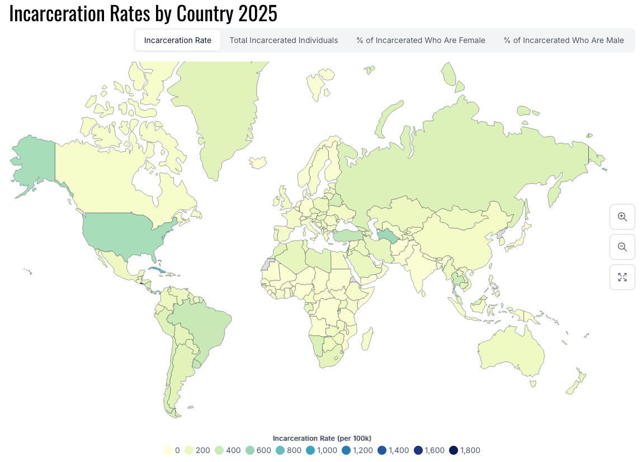

1. What appears to be the purpose of the chart?
The chart compares (incarceration rate) in year (2025), helping viewers identify geographic differences.

2. What kind of chart is this?
A (shaded/filled/choropleth map).

3. What data does it appear to be encoding and how is it encoding it?
Data encoded | Encoding | Explanation
Incarceration rate | Colour scale | B. Yellow indicates lower rates; dark blue indicates higher rates.
Country location | Geographic position | A. Countries appear at their map locations.
The legend explains the colour scale, ranging from 0 to 1,800 prisoners per 100,000 people.

4. Are there any interactive features? If so, what are they and how are they used?
Feature | Intended use
Zoom and pan controls | A. Enlarge or move around the map to examine countries more closely.
Hover tooltips | B. Display a country’s name and exact incarceration rate when hovering over it.

5. What features does it use to try to get its message across?
Feature | How It Helps Convey the Message
Sequential color scale | C. Shows differences between low and high rates.
Interactive filters | F. Allows exploration of different measures.
World map layout | A. Provides a global overview and geographic context.
Colour legend | E. Explains the colours and rate values.
Zoom controls | B. Allows closer inspection of small countries.
Chart tile | D. Identifies the topic and stated year.

6. Which design do you think is best and why?
Design feature | Good design | Bad design
Rates per 100,000 support comparisons across countries of different population sizes. | ☒ | ☐
The legend links colours to numerical rates. | ☒ | ☐
Many countries have similar pale colours, making differences difficult to distinguish. | ☐ | ☒
Tabs allow users to explore different measures. | ☒ | ☐
Small countries are difficult to identify in the global view. | ☐ | ☒
The data source is provided, helping viewers verify the information. | ☒ | ☐

Visualisation 4:
Reference: https://www.prisonpolicy.org/global/2024.html
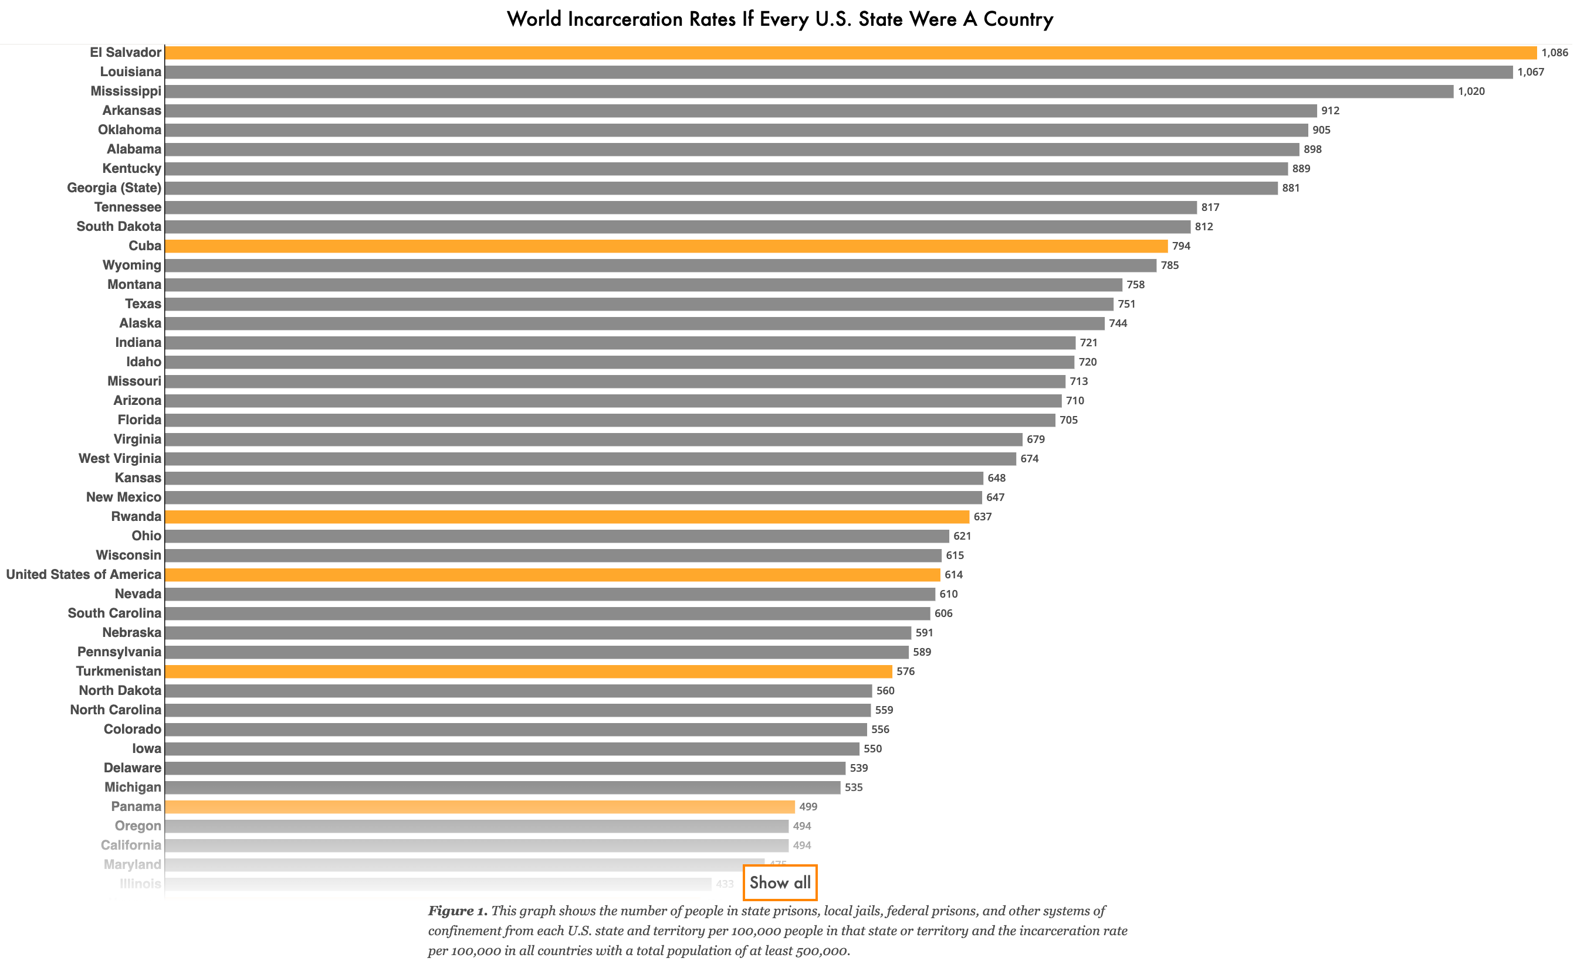

1. What appears to be the purpose of the chart?
The chart compares (the incarceration rates between US States and other countries), showing that many U.S. states have rates higher than those of numerous countries.

2. What kind of chart is this?
A (horizontal bar chart), ordered from highest to lowest rate.

3. What data does it appear to be encoding and how is it encoding it?
Data Encoded | Encoding Method | Explanation
Incarceration rate per 100,000 people | Bar length | C. Longer bars indicate higher rates.
State or country identity | Text labels | D. Names identify each state or country.
Category (U.S. state vs country) | Hue Colors | A. Grey represents states; orange represents countries, including the U.S. total.
Exact incarceration rate | Numerical labels | B. Numbers at bar ends show exact rates.

4. Are there any interactive features? If so, what are they and how are they used?
Yes, there are two interactive features.
Interactive feature | Description
“Show all” button | A. Expands the chart to display additional states and countries.
Hover tooltip | B. Displays the state or country name and exact rate when hovering over a bar.

5. What features does it use to try to get its message across?
Feature | How It Helps Convey the Message
Bar lengths | C. Makes rate differences easy to compare.
Grey and orange colours | A. Distinguishes U.S. states from countries.
Descending order | E. Makes the highest rates easy to identify.
Names and numerical labels | B. Identifies places and shows exact rates.
Explanatory caption | D. Explains the measure and population coverage.
Horizontal layout | F. Accommodates long state and country names.

6. Which design do you think is best and why?
Design feature | Good design | Bad design
Bars share a common baseline, making rates easy to compare. | ☒ | ☐
Descending order makes the ranking clear. | ☒ | ☐
Contrasting colours distinguish states from countries. | ☒ | ☐
Small text makes names and values difficult to read at the displayed size. | ☐ | ☒
The visualization lacks a colour legend explicitly explaining grey and orange. | ☐ | ☒
Numerical labels provide exact rates without requiring estimates. | ☒ | ☐

Visualisation 5:
Reference: https://www.prisonpolicy.org/global/2024.htmlLinks to an external site. (scroll down)
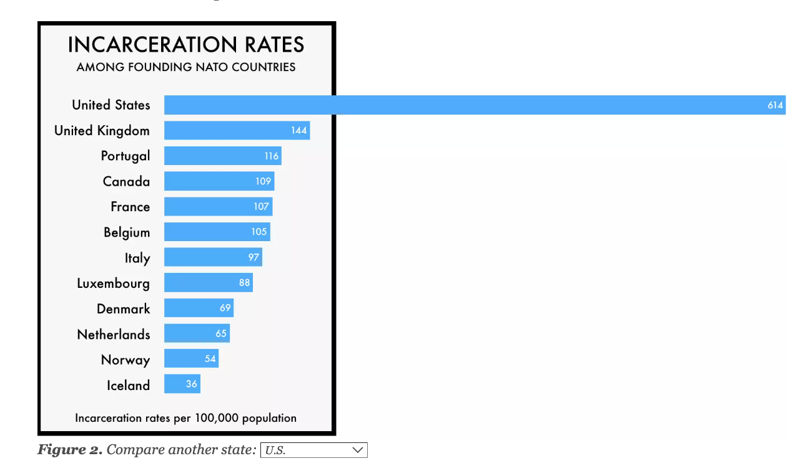

1. What appears to be the purpose of the chart?
The chart compares (incarceration rates between US states and NATO countries) highlighting the much higher U.S. rate compared with the other countries shown.

2. What kind of chart is this?
A (horizontal bar chart), ordered from highest to lowest rate.

3. What data does it appear to be encoding and how is it encoding it?
Data Encoded | Encoding Method | Explanation
Incarceration rate per 100,000 population | Bar length | Longer bars indicate higher rates.
Country name | Text labels | Names identify each country.
Exact incarceration rate | Numerical labels | Values inside bars show exact rates.
Ranking | Vertical position | Higher rates appear nearer the top.

4. Are there any interactive features? If so, what are they and how are they used?
Yes. The chart includes an interactive dropdown below the bars.
Interactive feature | How it is used
State selection dropdown | Select a U.S. state to replace the national U.S. bar with that state’s incarceration rate.
Dynamic chart update | Compare the selected state’s rate with those of the founding NATO countries.

5. What features does it use to try to get its message across?
Feature | How it helps — answer
Long U.S. bar | Emphasises the much higher U.S. rate.
Consistent blue colour | Keeps attention on bar-length differences.
Descending order | Makes the highest and lowest rates easy to identify.
Country names and numerical labels | Identifies countries and shows exact rates.
Interactive dropdown | Allows users to customise the comparison.
Title and rate caption | Identifies the comparison group and measurement unit.

6. Which design do you think is best and why?
Design feature | Good design | Bad design
Bars share a common baseline, supporting accurate comparison. | ☒ | ☐
Descending order makes the ranking clear. | ☒ | ☐
Numerical labels provide exact rates. | ☒ | ☐
The heavy black border adds clutter and cuts through the bar area. | ☐ | ☒
The caption clearly states the measurement unit. | ☒ | ☐
The data source is not provided. | ☐ | ☒

